投影程序鉴定表
Verification Sheet for Projection Program

编号  Serial No. | (1) |  |  |  | 单位  Shop | (2)
项目代号  Project | (3) |  |  |  | 日期  Date | (4)
序号  No. | 零件号  Part No. |  | 投影程序号  Program No. |  | 版次  Rev. | 更改单号  Change Sheet |  | 是否合格  Yes/No
(5) | (6) |  | (7) |  | (8) | (9) |  | (10)
兹证明按上述程序经过首件/部分首件检验鉴定，生产的零件完全符合图纸、技术规范以及合同/订单要求。
FAI/Partial FAI has been performed on the whole projection programs detailed. The products manufactured by the projection program above conform to specifications, drawings, and contact/purchase order.
编制 Prepared By |  | （11） |  | 校对 Checked By |  |  | （12）
检验 Inspect By |  | （13） |  | 批准 Approved By |  |  | （14）

填写说明Instructions for Filling：

（1）生产厂工艺员填写投影程序鉴定表编号，编号的组成结构如下图，投影程序鉴定表（FM1406-21）文件类别代码为PH；如“S5C-PH9400-022”。
The technologist of the planner shall fill in the number of projection program identification form. The composition of the number is shown in the figure below. The document category code of projection program identification form (FM1406-21) is PH; Such as "S5C-PH9400-022".
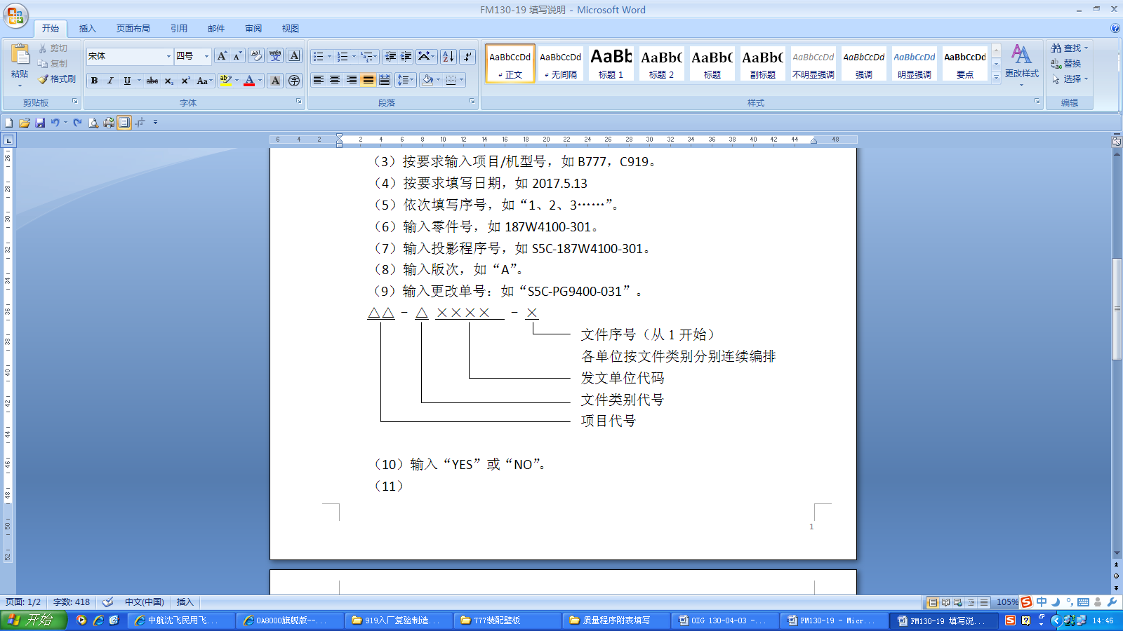
Text serial number (starting from 1)
Each unit shall be arranged consecutively according to document type
Code of issuing unit
Document category code
Project code

（2）生产厂工艺员填写单位名称，如“零件制造中心”。
The planner of the manufacturer fills in the unit name, such as "Parts Manufacturing Center".
（3）生产厂工艺员填写项目代号。
The planner of the manufacturer fills in the project code.
（4）生产厂工艺员填写投影程序的鉴定日期。
The planner of the manufacturer fills in the identification date of the projection program.
（5）生产厂工艺员填写序号，如“1、2、3……”。
The planner of the manufacturer shall fill in the serial number, such as "1, 2, 3...".
（6）生产厂工艺员填写零件号，如187W4100-301。
The planner of the manufacturer fills in the part number, such as 187W4100-301.
（7）生产厂工艺员填写投影程序号，如S5C-187W4100-301。
The planner of the manufacturer fills in the projection program number, such as S5C-187W4100-301.
（8）生产厂工艺员填写投影程序版次。
The planner of the manufacturer fills in the projection program version.
（9）生产厂工艺员填写投影程序更改单号。
The planner of the manufacturer fills in the projection program change sheet No.
（10）生产厂检验员依据投影程序鉴定结果，填写“是”或“否”。
The inspector of the manufacturer shall fill in "Yes" or "No" according to the identification result of projection procedure.
（11）内容由生产厂工艺员签字。
The content shall be signed by The planner of the manufacturer.
（12）内容由生产厂技术室主任签字校对。
The contents shall be signed and proofread by the director of the technical office of the manufacturer.
（13）内容由生产厂检验员签字。
The content shall be signed by the inspector of the manufacturer.
（14）内容由生产厂技术副厂长签字批准。
The content shall be signed and approved by the technical deputy director of the manufacturer.

